**CSE102L Computer Programming Lab**

**LAB # 9**



**2020**

**Submitted to:**

**Engr. Abdullah Hamid**

**Submitted by:**

**TAYYABA**

**Registration No :**

**19PWCSE1854**

**Semester: 2nd**

**Class Section:** **C**

“On my honor, as student of University of Engineering and Technology,

I have neither given nor received unauthorized assistance on this

academic work.”

August , 5, 2020

**Department of Computer Systems Engineering**

**University of Engineering and Technology, Peshawar**

**Pointer and References in Arrays and Functions**

**Objectives:** To understand pointer role in arrays and functions.

**Task 1**

**Title:**

Write a C++ program where you make an array of 10 elements and get all elements value from user and display all elements using pointers.

**Code:**

#include<iostream>

using namespace std;

main()

{

int a[10], *ptr;

ptr = &a[0];

for(int i = 0; i<10 ; i++)

{

cout<<"Please Enter value of Element "<<i+1<<" : ";

cin>>*(ptr + i);

}

for(int n = 0; n<10 ; n++)

{

cout<<"Value of Element "<<n+1<<" : "<<*(ptr + n)<<endl;

}}

**Output:**

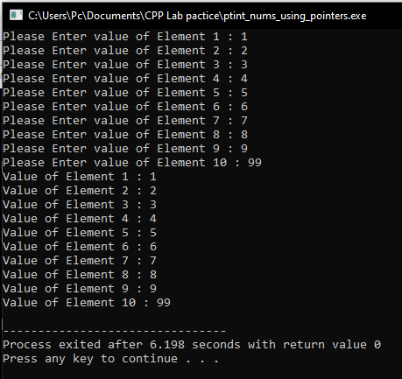

**Task 2**

**Title:**

Write a C++ program where you create a 12 elements array and take user from input and then display them (3 elements in a row) using pointers.

**Code:**

#include<iostream>

using namespace std;

main()

{

int x[12],h=0,*ptr;

ptr = &x[0];

for(int i=0;i < 12;i++)

{

cout<<"Enter value # "<<i+1<<" ";

cin>>*(ptr + i);

}

for(int i=1;i < 5;i++)

{

for(int j=0;j<3;j++)

{

cout<<"Value # "<<h+1<<" = "<<*(ptr + h)<<"\t";

h++;

}

cout<<endl;

}}

**Output:**

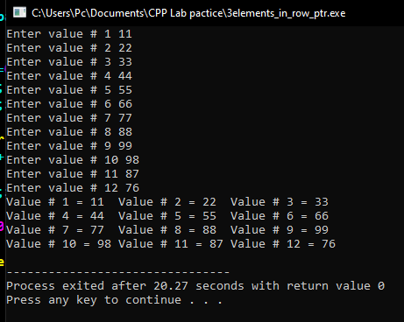

**Task 3**

**Title:**

Write a C++ program where user enters values for 5 element array and then displays its sum.

**Code:**

#include<iostream>

using namespace std;

main()

{

int a[5], *ptr = &a[0] , sum = 0;

for(int i = 0 ; i < 5 ; i++)

{

cout<<"Please Enter Value Of Element "<<i+1<<" : ";

cin>>*(ptr + i);

}

for(int i = 0 ; i < 5 ; i++)

{

sum =sum + *(ptr + i);

}

cout<<"Total sum of all element entered in array is : "<<sum;

}

**Output:**

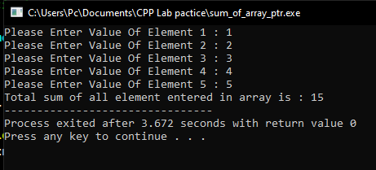

**Task 4**

**Title:**

Write a C++ program where you create a 5 element array (hard code values) and then call a function average which takes pointer to the beginning of array and size of that array as its parameters and computes average.

**Code:**

#include<iostream>

using namespace std;

void average(int* , int);

main()

{

int a[5]={2,3,4,5,6};

for(int i = 0 ; i<5 ; i++)

{

cout<<" a["<<i<<"] = "<<a[i]<<endl;

}

average(a, 5);

}

void average(int *x, int size)

{

int sum=0;

for(int i = 0 ; i<5 ; i++)

{

sum = sum + *(x + i);

}

cout<<"The Average of 5 Elements is : "<<(float(sum)/size);

}

**Output:**

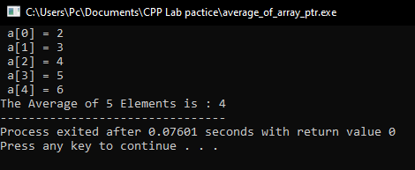

**Task 5**

**Title:**

Write a C++ program where user enters values into a 5 element array using pointers and then enters two separate variables which indicates the indices of elements that need to be added in function that only accepts pointers and parameters.

**Code:**

#include<iostream>

using namespace std;

main()

{

int a[5],*ptr = &a[0], n, m, sum = 0;

for(int i = 0 ; i<5 ; i++)

{

cout<<"Please Enter Value Of array Element "<<i+1<<" : ";

cin>>*(ptr + i);

}

cout<<"\n\nPlease Enter the index number to sum : ";

cin>>n;

cout<<"Please Enter the index number to sum : ";

cin>>m;

sum = *(ptr+ (n-1)) + *(ptr + (m-1));

cout<<"The sum of Element "<<n<<" and Element "<<m<<" equal to : "<<sum;

}

**Output:**

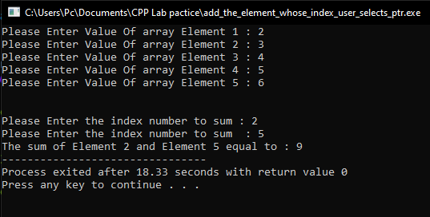

**Task 6**

**Title:**

A program which has four functions (addition, subtraction, division and multiplication) and a calculate function which takes two numbers and a pointer to function. Calculate passes these numbers to appropriate function.

**Code:**

#include<iostream>

using namespace std;

float addition(int *a, int *b);

float subtraction(int *a, int *b);

float division(int *a, int *b);

float multiplication(int *a, int *b);

float calculate(int *a, int *b, float((*function)(int*, int*)));

int main()

{

int a,b,c;

cout<<"Enter First number: ";

cin>>a;

cout<<"Enter Second number: ";

cin>>b;

cout<<" \n\n To Add Enter = 1 \n To Subtract Enter = 2 \n To Multiply Enter = 3 \n To Devide Enter = 4 \n\n Enter the operation = ";

cin>>c;

switch(c)

{

case 1:

cout<<"\nResult of Addition is "<<calculate(&a, &b,addition)<<endl;

break;

case 2:

cout<<"\nResult of Subtraction is "<<calculate(&a, &b,subtraction)<<endl;

break;

case 3:

cout<<"\nResult of Multiplication is "<<calculate(&a, &b,multiplication)<<endl;

break;

case 4:

cout<<"\nResult of Devision is "<<calculate(&a, &b,division)<<endl;

break;

default:

cout<<"Wrong Entry";

break;

}

}

float calculate(int *a, int *b, float((*function)(int*, int*)))

{

return function(a, b);

}

float addition(int *a, int *b)

{

return *a + *b;

}

float subtraction(int *a, int *b)

{

return *a - *b;

}

float multiplication(int *a, int *b)

{

return *a * *b;

}

float division(int *a, int *b)

{

return ((float) *a) / *b;

}

**Output:**

